**VAMSHI MYLAVARAPU**

**700759652**

**ASSIGNMENT 2**

**NEURAL NETWORKS AND DEEP LEARNING**

1. **A)** Write a program that takes two strings from the user: first name, last name. Pass these variables to full name function that should return the (full name).

o For example: ▪ First name = “your first name”, last name = “your last name” ▪ Full name = “your full name”

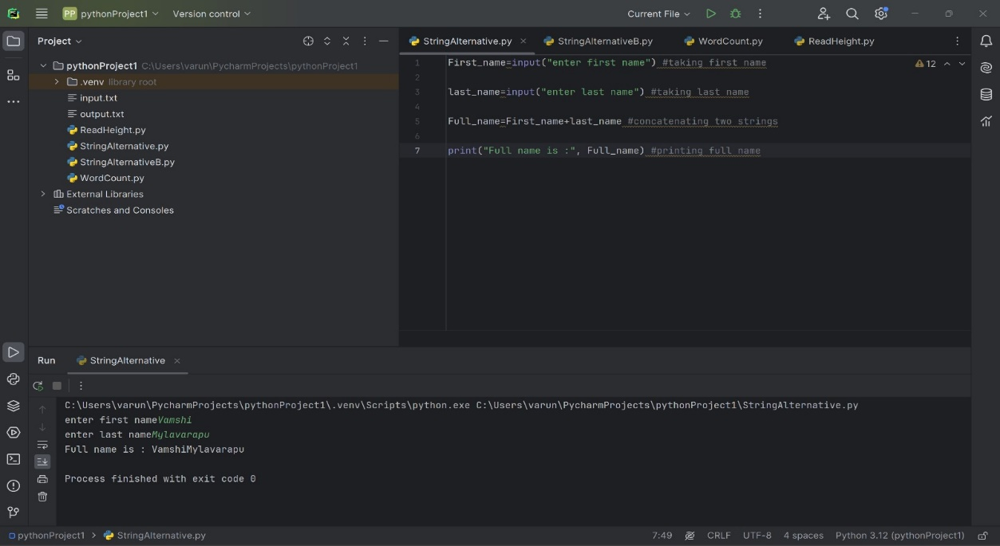

**B)** Write function named “string alternative” that returns every other char in the full name string. Str = “Good evening” Output: Go vnn

1. Write a python program to find the wordcount in a file (input.txt) for each line and then print the output. o Finally store the output in output.txt file.

Example: Input: a file includes two lines: Python Course Deep Learning Course

Output: Python Course Deep Learning Course

Wordcount: Python: 1 Course: 2 Deep: 1 Learning: 1

1. Write a program, which reads heights (inches.) customers into a list and convert these heights to centimeters in a separate list using: 1) Nested Interactive loop. 2) List comprehensions Example: L1: [150,155, 145, 148] Output: [68.03, 70.3, 65.77, 67.13]

